**Cryptography & Network Security**

**PRN - 2019BTECS00026**

**Name - Niraja Vasudev Kulkarni**

**Batch - B1**

**Assignment - 9**

**Title**: Prime Factorization

**Aim:** To Demonstrate Prime Factorization

**Theory:**

RSA Laboratories states that: for each RSA number n, there exists prime numbers p and q such that

n = p × q.

The problem is to find these two primes, given only n.

Code:

from sympy.ntheory import factorint

import math

def factors_int(num):

    poss_p = math.floor(math.sqrt(num))

    if poss_p % 2 == 0:

        poss_p += 1

    while poss_p < num:

        if num % poss_p == 0:

            return poss_p

        poss_p += 2

# n = 955933250882005692895759

n = int(input("Enter n: "))

print("Prime factors are: ", factorint(n))

Output:

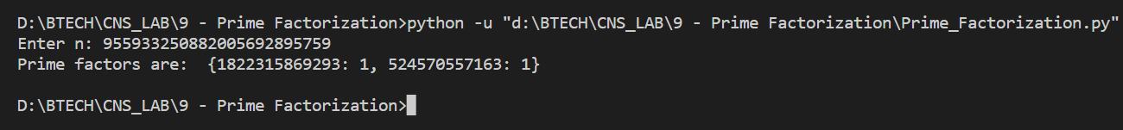

**Conclusion:**

The RSA Factoring Challenge was a challenge put forward by RSA Laboratories to encourage research into computational number theory and the practical difficulty of factoring large integers and cracking RSA keys used in cryptography. They published a list of semiprimes (numbers with exactly two prime factors) known as the RSA numbers, with a cash prize for the successful factorization of some of them.